|  |
| --- |
| Project |
| Samy Yousef samy Alkojok  120200510  Store |

1)_Requairment :

* Store : I do add , delete , update , edit and show :

The store is added by the requirements that were requested and the category is selected by a drop-down list.

* Category : I do add , delete , update , edit and show.
* Admin : I do add , delete , update , edit and show.
* Logout : logout from dashboard.
* Rate : Just insert and Show.

2)_Bonus :

* I tried not to evaluate more than once, but it did not work completely. I made a table in the data base named is_rate and made the mac address and the process of adding it to it and then I deleted the code, you can see it in the data base

3)_Bonus Other :

* Admin : I do add , delete , update , edit and show.

For the manager, any manager who entered the administration page can see only his private profile and he cannot see other managers and he cannot delete or modify them and there is an option to deactivate the manager.

If the admin is not active, he cannot log in and a message appears that it is not active.

4)_Software Design :

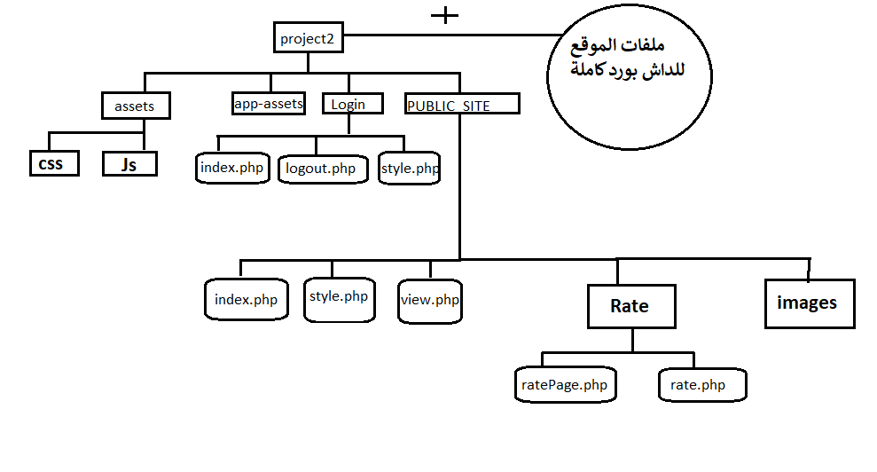

5)_Templets :

* Add Rating , Rating Account

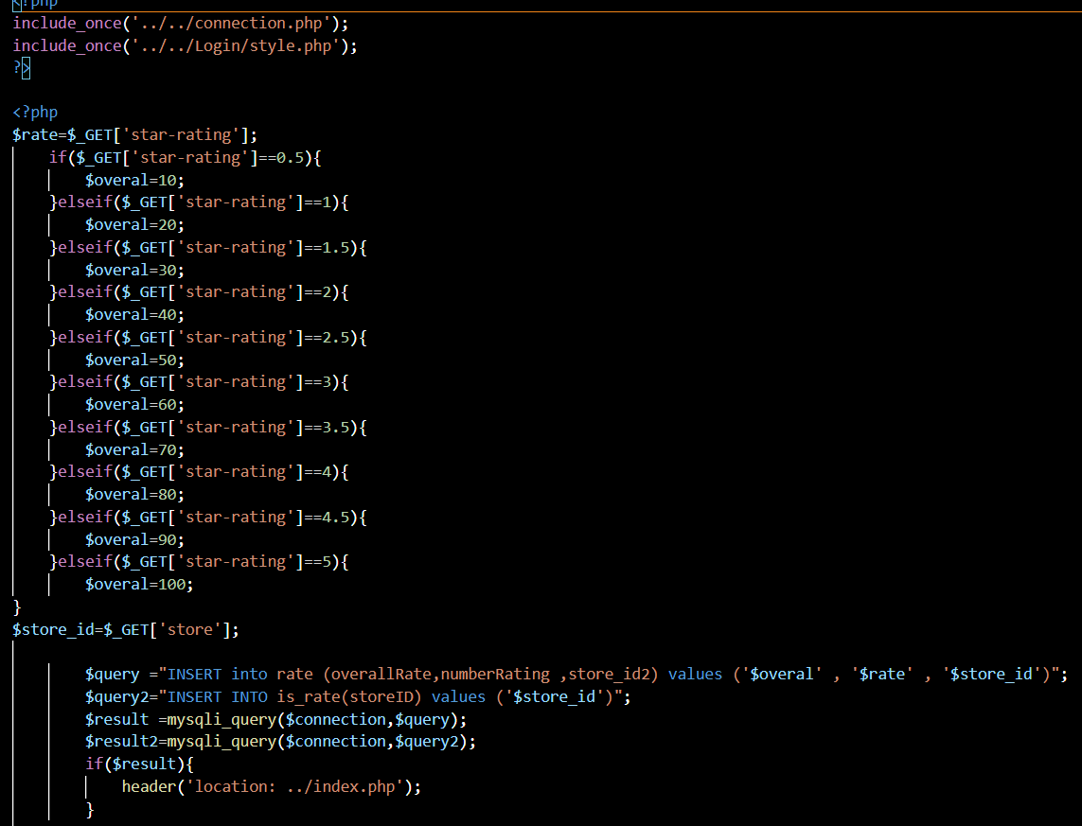

* Add Admin

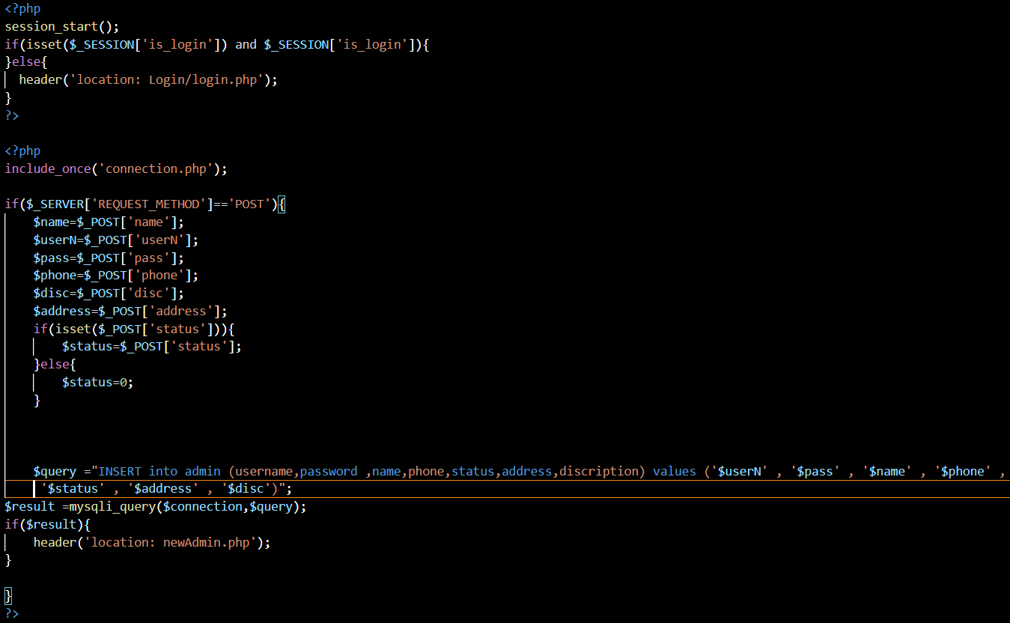

* Delete Admin

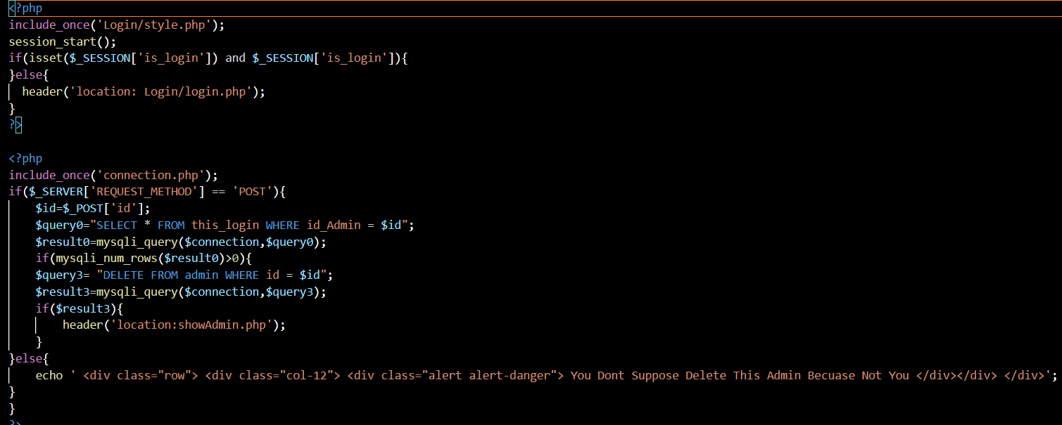

* Update Admin

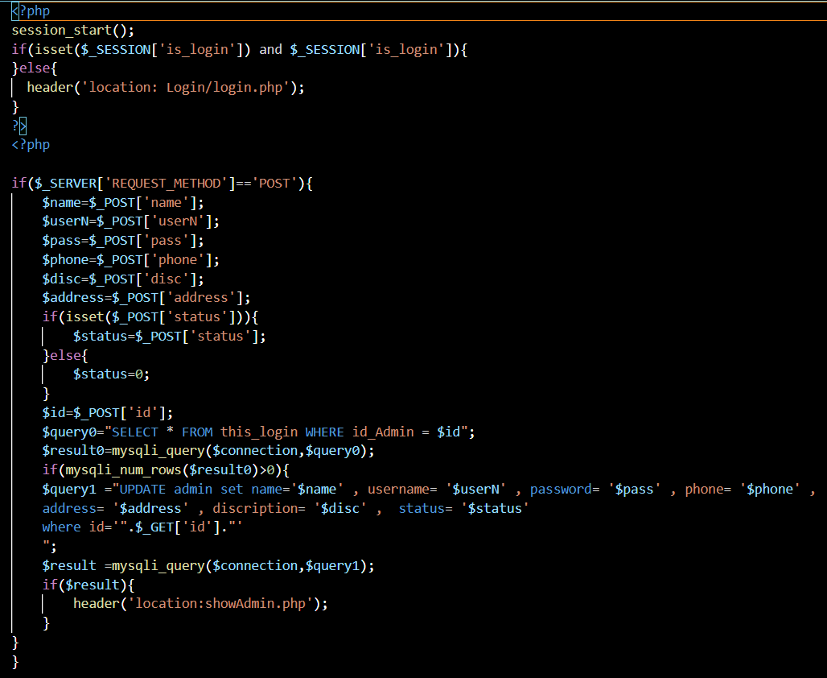

* Admin Is Login or not To find out the admin account entered

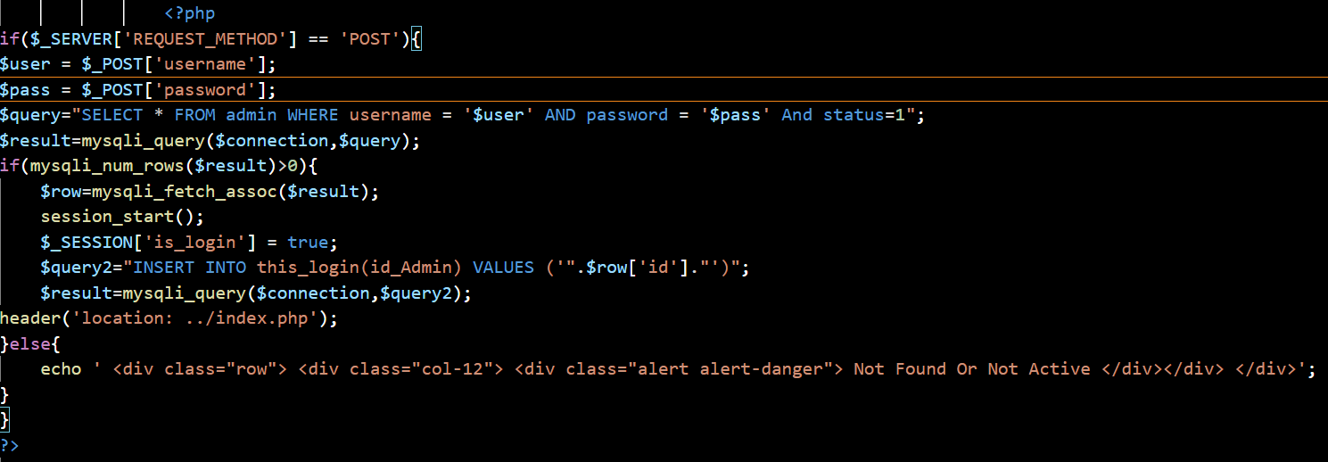

* An admin is deleted in this_login when the session is closed

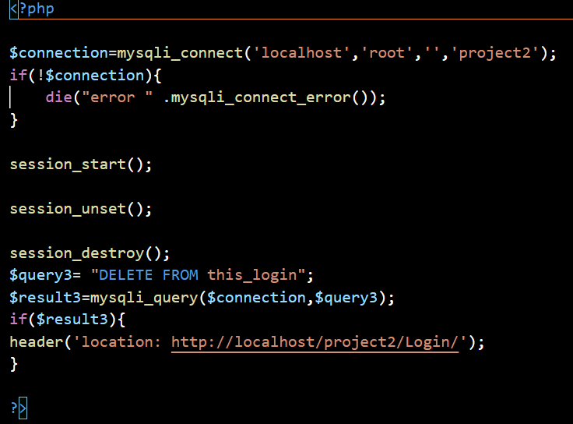

{ DataBase Arcitecture }:

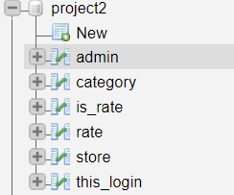

* Admin :



* Category:



* Is_rate:

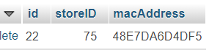

* Rate:



* Store :



* this_Login:

